Introduction

The intelligent, ceiling-mounted office assistant Aerius is capable of autonomously recognizing, classifying, and overseeing office supplies. Inspired by the concept of ‘air’ or ‘aerial’ mobility, the name ‘Aerius’ was chosen for its sleek, futuristic feel and to allude to the robot's ceiling-mounted design. The design of an autonomous office robot will be covered in this study, along with its purpose, necessary competencies, hardware and software architecture, dataset plan, safety precautions, and financial constraints.

Mission & Task:

The goal of Aerius is to keep a clean, efficient, and organized work environment by locating lost items, classifying them, placing them in appropriate storage areas, and working with other cleaning or maintenance robots. Aerius saves energy and space by integrating seamlessly into the ceiling while not in use and moves along a ceiling mounted grid or rail system to reach different areas of the office efficiently. It can be activated automatically or by command to carry out functions like assistance, inventory control, organization, and light cleaning coordination.

Its telescopic arm only stretches out to handle objects when necessary with deployment planned according to its present X, Y, and Z locations along the ceiling rail system in order to reach items precisely and safely.

A survey entitled ‘P-touch Means Business’ estimated that disorganization in the workplace causes each employee to lose approximately 76 working hours per year, resulting in over USD 177 billion lost annually across organizations (Brother via StartupNation, 2011). Aerius addresses this inefficiency by automating organization and reducing clutter.

**Detailed Task List**

**1. Scanning and Mapping the environment**

* Uses LiDAR and camera sensors to scan the area after deploying from the ceiling.
* Creates or modifies a spatial map of the floor zones, drawers, shelves, and desks.
* Identifies locations that are dirty or cluttered and records them for cleaning cooperation.

**2. Identifying and Detecting Items**

* Identifies common office supplies (pens, notebooks, staplers, folders, cups, and technological devices) using computer vision and artificial intelligence.
* Distinguishes between misplaced and categorized items.
* Identifies possible cleaning needs by detecting dust or surface mess using the sensor signals found in each corner on the floor.

**3. Setting priorities and making decisions**

* Examines workstation conditions to determine what needs to be done (cleaning robot assistance, sorting, and tidying).
* Sets priorities according on user preferences, item kind, or urgency.  
  For planned maintenance procedures, it interfaces with the office management system.

1. **Planning and Navigation**

For specific tasks, its telescopic robotic arm extends from the ceiling mount.

* Using a vertical Z-axis mechanism that enables precise positioning above any region in the office and motorized carriages that slide along the X and Y axes, Aerius travels along a ceiling-mounted rail system set up in a 3D grid.
* In order to prevent collisions with furniture or objects, stepper motors and sensor-guided alignment provide precise, seamless travel along the rails.  
  Determines the best shortest routes for placing and retrieving objects safely.  
  Works in tandem with cleaning bots to prevent collisions or overlap while in operation.

1. **Manipulation of Objects**

* Outfitted with a multi-fingered, soft-grip end effector for safe handling of objects with unusual shapes or that are fragile.
* Modifies angle and grip strength according to fragility and material.

1. **Placement & Organization of Items**

* Has the ability to automatically rearrange meeting tables or common office spaces after use.
* Sorts items into smart drawers or designated storage areas; modifies organizational patterns according on accessibility and usage frequency.

1. **Stock & Monitoring**

* Keeps track of every object that has been identified and its location in a digital catalogue.  
  Alerts the user if something is missing. For example, ‘Your charger has been off the desk since yesterday.’
* Helps find lost objects, such as ‘Your black pen is in drawer in the left.’

1. **User Control & Management**

* The device can react to voice requests, gesture inputs, or directions from mobile apps, such as ‘Aerius, organize my desk.’
* Provide task completion and inventory summary feedback either on-screen or audibly.
* Custom scheduling is possible for regular cleaning or organization.
* Users able to schedule an action such as ‘Bring notebook to desk tomorrow at 8’.

1. **Tidying & Cleaning Mode**

* Equipped with a micro vacuum or magnetic mini-cleaner to remove dust, paper clips, and small debris.
* Have sensors in strategic places in corners on the floor that communicates with Aerius to know when the next cleaning session is due.

1. **Docking & Self-Maintenance**

* Activates wireless charging and self-cleaning when it retracts smoothly into its ceiling bay
* Conducts diagnostics on sensors, grasp mechanisms, and drone modules
* Automatically updates its firmware over a cloud connection.

1. **Mode of Security and Monitoring**

* When the office is empty, it serves as an environmental monitor and can identify unwanted entry, lost objects, or strange movement.
* Capable of sending real-time images or triggering warnings to the office security system.

1. **Efficiency in Energy Use**

* Employs adaptive sleep mode, turning on only in response to motion detection or summoning; chargesvia wireless docking or solar ceiling panels when retracted.
* Makes use of clever scheduling to optimize energy use.

1. **Adaptive Education**

Gains knowledge over time from user behavior and workspace trends.  
• Recognizes objects that are often utilized (e.g., keeping your notebook accessible every day).   
• Reorganization is suggested by the phrase ‘Would you like me to move unused papers to the storage shelf?’

Below is a flowchart representation of the basic function of Aerius:

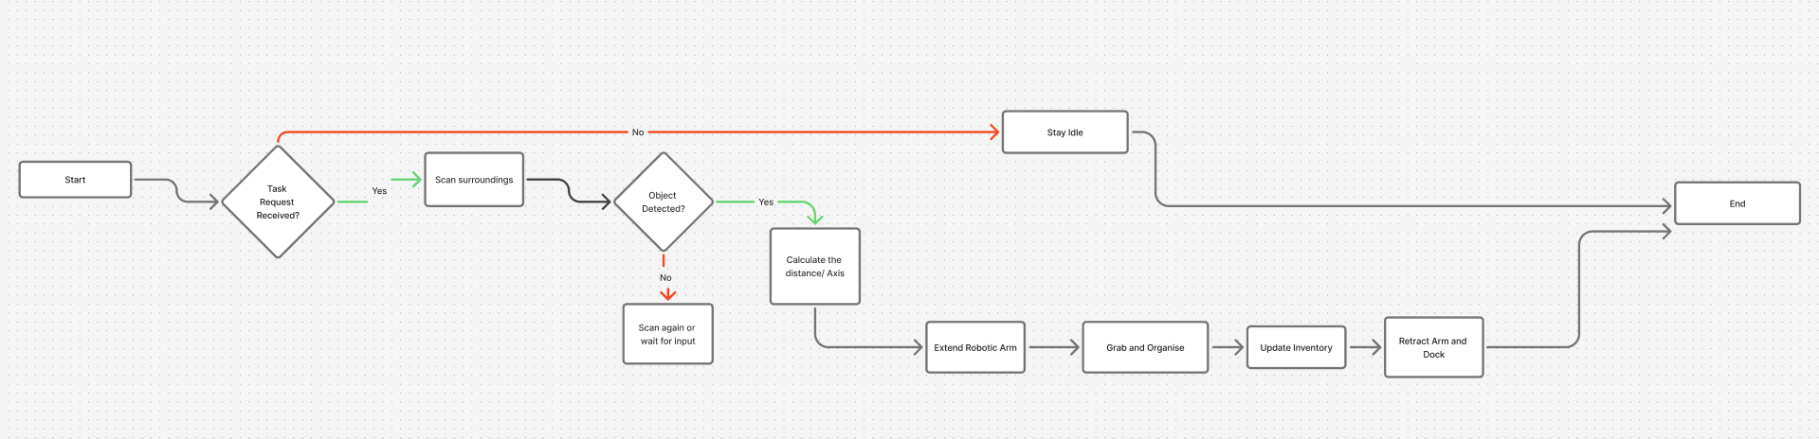

Required Skill:

In the table below, Aerius’s required skills, description of the input and output criteria, along with the success criteria are explained.

|  |  |  |  |  |
| --- | --- | --- | --- | --- |
| Skills and Description | Interface | Input Criteria | Output Criteria | Success Criteria |
| Perception and Object Recognition:  finds workplace supplies, obstructions, messy spaces, and surfaces that require cleaning. | RGB + Depth Cameras: To recognize items, forms, and clutter, take pictures and record depth information simultaneously.  LiDAR Sensors: Make 3D spatial maps and calculate the distances to barriers. Using LiDAR images, 3D Point Cloud Processing creates spatial models to precisely arrange objects.  Ultrasonic / Proximity Sensors: Detect nearby obstacles, humans, or furniture edges for safety. Convolutional neural networks, or CNNs, are used to classify objects (e.g., differentiating between a pen and a ruler).  Floor Corner & Edge Sensors: Check corners and edges for dirt, debris, or lost objects.  Infrared / Low-Light Sensors: Identify items in darkened or low-light conditions.  Multi-sensor fusion(Wang H et al. (2025): combines data from multiple sensors which involves to identify, locate and track targets.  **ResNets:** deep learning model used to extract key object features and support classification. (He et al, 2020)  **YOLOx:** object detection algorithm that gives location of object on a frame using bounding boxes. ( Wang. et al, 2023) | Streams of data from LiDAR, cameras, ultrasonic, and edge/floor sensors.  LiDAR is a critical tool used for precise localization and mapping.  Proximity sensor uses sound wave reflections to ensure safe and short-range navigation, preventing collisions.  Floor and Edge sensors use infrared or optical readings from downward-facing sensors during navigations to prevent falls near or edges.  Infraded sensors use infrared light rays to navigate in poorly lit environments  Multi Sensor fusion combines data from sensors above to enhance robustness against noise.  ResNet uses RGB and depth image, feature extraction and feature matching for classification.  YOLOx uses RGB image to locate objects in real-time camera frames using bounding box.  Motion detection data and lighting conditions.  Object database reference for known item matching.  Neural network weights that have already been trained for item recognition. | The kind, position, size, and orientation of the recognized items are listed.  Places that have been marked as untidy, messy, or unclean.  Navigation and task planning using an obstacle map.  Notifications of abnormalities or unknown things.  Scores of confidences for identified objects (e.g., 87% stapler, 92% pen). | Detects at least 95% of office supplies correctly.  Reliably detects clutter, filth, or misplaced objects with a false positive rate of less than 5%.  Warn employees precisely about odd or unknown objects.  Boundary Detection Test which accurately identify the edges of the workspace in 50 randomly selected test zones with an error margin of ≤ 2 cm.  Validation of Latency: The perception pipeline operates in real time by processing frames in less than 300 milliseconds.  Test of Environmental Mapping with 3D model created across a 10 m² workspace with ≤ 5% spatial distortion. |
| Identification(Localization) and Mapping:  Maintains spatial awareness of the office layout to ensure that arm module can be navigated safely. | System of ceiling rails with encoders and servo motors on the X, Y, and Z axes. With the use of Simultaneous Localization and Mapping (SLAM), Aerius may move along the ceiling rails and create and update a dynamic 3D map.  **Wheel Encoders:** Provide point-wise position and velocity data used by the odometry system to estimate linear motion and predict constant velocity.  RGB + Depth Cameras: Captures RGB color images with depth.  LiDAR / Depth Sensors: Scan environment for 3D mapping.  IMU and encoder data are used in Kalman Filtering to provide accurate motion estimation.  Rail movement data is transformed into three-dimensional workspace coordinates using the Coordinate Transformation Algorithm.  Navigation, control, and cleaning coordination modules communicate with one another through the ROS (Robot Operating System). | Data from LiDAR and depth sensors for scanning the area.  Motion, cleanliness, and occupancy data from floor sensors.  Updates on item position in real time from the object recognition module.  Task requests, such as ‘clean my desk’ or ‘organize desk.’  IMU data such as acceleration, angular velocity.  **Odometry Estimation:** Combines IMU and wheel encoder data to estimate the robot’s motion and predict its next pose.  • **Motion Correction:** LiDAR data refines predicted motion by comparing measured distances to previously observed map features, reducing drift.  • **Mapping and Feature Detection:** The camera and LiDAR continuously detect new features and landmarks. Point cloud data is spatially subsampled and updated based on encoder and motion information.  • **Sensor Fusion:** A multi-sensor fusion module integrates inputs from the IMU, camera, LiDAR, and encoders to generate a more accurate and stable pose estimation  **Loop Closure:** When the robot revisits a previously mapped location, the system detects loop closure, aligns the new map segment with the old one, and corrects accumulated localization errors. | Real time 3D office map including floors, walkways, shelves, and desks.  Locate the arm in relation to barriers and objects.  Dynamic warnings for blocked routes or layout modifications.  Signals to cleaning robots that are coordinated (to avoid overlap).  ‘Path complete,’ ‘Obstacle detected’ are the status updates displayed on the system dashboard. | Aerius must arrive at the destination coordinates with a variance of no more than 2 cm in order to pass the path accuracy test.  Validation of Collision Avoidance: In 20 live and 100 simulated trials, the system successfully avoids both static and dynamic obstacles.  Synchronisation Test where ROS communication logs confirm that no path overlap with other robots was found.  Task Completion Efficiency: Under various load situations, path planning and execution are finished within 10% of the predicted time threshold.  Floor Sensor Integration Test where in at least 95% of test cases, the cleaning trigger was correctly detected and communicated to Aerius. |
| Path Planning ***  How will our robot plan a path to its destination object position? | RGB-D Camera- takes constant RGB colour images.  LiDAR- measures distances of the robot to objects in its surroundings.  IMU- measures the robot’s acceleration and the rotation of the object.  **Self-Improved Ant Colony(SI ACO)**: combines data from the camera and LiDAR to find the shortest path to the object. Zhang et al (2023) explains that this algorithm, just like an ant navigating a space, the robot explores aimlessly at first. Data points are updated to a rastic map and the heuristic function to score how close it is to the goal. Gaussian sampling allows the robot to explore alternative paths near the best-known route — improving adaptability and avoiding local optima. (Zhang et al, 2023) | Sensor fusion data(visual and spatial maps | Optimized path coordinates from the robot’s current position to the target. Shortest route to the object | The robot successfully identifies a collision-free path to the object.  Travel distance and time are minimized. |
| Organizing and scheduling: decides on the best order for tasks and carries out planned actions. | Inventory Database API: gives the location, kind, and frequency of use of the object. A* path planning algorithm to find the shortest route.  Task Scheduler / Planner Interface: obtains schedules and priorities set by the user.  User App / Voice Control API: takes orders and schedules from employees.  Robot Operating System (ROS) / Control Software: creates work plans that are optimized by combining perceptual and localization data.  Smooth acceleration, deceleration, and accuracy in every axis are guaranteed via PID motor control. | Data about object placements and priorities.  Notifications of cleaning or tidying from floor corner/edge sensors.  Commands, schedules, or preferences set by the user.  Current state of cleaning robots, drones, and arms. | Task sequence optimization for cleaning, drone, and arm robots.  Robots or employees are notified about planned tasks.  Orders for arming and operating a drone.  Strategies for resolving conflicts when several tasks compete for the same resources. | Validation of User Commands that accurately understands and performs voice and scheduled commands in at least 98% of attempts.  Response Time Test: The system chooses its next course of action within ≤ 1 second of receiving input.  Adaptability Test: Following 20 iterative sessions, the reinforcement learning model increases decision efficiency by at least 10%. |
| Arm control and manipulation: Regulates a telescopic arm to pick and position objects safely. | Telescopic Robotic Arm: To pick or place objects, it extends and retracts. Inverse Kinematics determines the necessary joint angles to attain goal coordinates in three dimensions.  Multi-Fingered End Effector with Force Sensors: adapts grip to the fragility of the object. The Force Control Algorithm dynamically modifies grip strength according on fragility and weight.  Arm Control Software / Motion Planning API: determines trajectories devoid of collisions. When unexpected resistance is detected, the collision detection and recovery system stop the action.  Proximity and Edge Sensors: Makes sure the arm stays away from staff or things nearby. When obstacles or people appear.  Dynamic Obstacle Avoidance (DWA) reroutes motion | Location, weight, size, and type of the target object as perceived by the user.  Limitations imposed by the localization module on the environment.  Proximity sensors to determine the locations of obstacles and the presence of people.  **Visual Servoing:**  The robot uses images taken by the eye to hand camera for visual servoing. And recognise the fiducials. AprilTag to detect the bounding box of the object. (Li et al, (2024))  **Depth based stopping:** when the frame from the image from the RGB-D Camera, the robot can stop at a certain depth of desired grasp distance. | Controls for grip and arm trajectory.  Arranging items in their proper workspaces or storage areas.  Retracting the arm after finishing a task.  Status updates for successful or unsuccessful tasks. | Test of Positional Accuracy where the end effector positions the object within a deviance of ≤ 1 cm from the target coordinate.  Response Time Test where for typical desk level tasks, arm positioning and movement must be finished in 5 seconds.  Grip Precision Test which capture and move ≥ 95% of test objects with different shapes.  Validation of Object Safety where no obvious damage or slippage during manipulation of any of the 100 test items. |
| Human Robot Interaction and Voice Command:  understands requests from employees via speech, gestures, or apps; it facilitates scheduling and the execution of commands. | Microphone Array / Noise Filtering Interface: records voice commands.  Gesture Detection Camera / Sensors: Detects human gestures. Pose estimation (MediaPipe/ OpenPose) for gesture recognition: deciphers basic motions (e.g., wave, point).  Mobile App / Web Interface:  Remote commands, task management, and scheduling are made possible. Commands are queued and executed by the Task Scheduler Algorithm according to rail location and priority.  NLP/ speech recognition, transforms spoken instructions into organized tasks.  Intent Classification Models (like BERT) analyze context and user requests. | Microphone array to record spoken orders.  Motion sensors and cameras are used to detect gestures.  Plans, preferences, or directions based on an application.  User identification and context for tailored communication.  Perception and location module feedback (e.g., present obstacles or task status). | Verification of the completion of tasks or modifications to the timetable.  Reorganization, cleaning, or inventory modification suggestions.  Notifications in the event of a conflict or an inability to finish a task.  The user receives visual or auditory confirmation that the command was received and executed.  Automate repetitive tasks by integrating with a scheduling system. | Gesture Recognition with ≥93% accuracy over 100 trials for the three main motions (stop, wave, and point).  Dialogue Robustness with ≥98% of unclear commands are successfully resolved or clarified.  100% of unauthenticated command attempts are rejected for security and authentication reasons.  Tested on 200 voice samples, speech recognition accuracy was 92 percent accurate in interpreting commands under typical office noise. |
| Inventory and Cleaning Management:  uses floor corner sensors to track things, update inventory in real time, and plan cleaning procedures. | Inventory Database API: Modifies the status and locations of objects. Real time changes are made to cloud based inventory logs by the Database Synchronization Module.  Floor Corner & Edge Sensors: identify congested areas, dirt, and debris. Edge Detection Filter (OpenCV-based) recognizes dust or particles near floor edges or corners.  Machine Learning-based Dirt Prediction Model: Predicts high-use zones requiring more frequent cleaning.  User App / Notifications API: Notifies users of areas that need attention or missing items. The Change Detection Algorithm compares the camera feed to a stored inventory map to identify missing or moved objects.  Communication with the user dashboard and other systems is made possible through IoT integration using the MQTT protocol.  RFID Reader and Tags: Make it possible to track tagged office assets continuously. | Edge sensors identify lost things; floor corner sensors identify dirt or small debris.  The perception system recognizes objects and determines their location, size, and kind.  Current information on things that are stored and utilized regularly.  Verifies that cleaning duties have been completed or points out spots that need attention. | Updated Inventory: Any recognized item's location, new items, or missing things are updated in real time in the database.  Tasks involving cleaning and tidiness: instructions given to robots that clean floors or signals for human assistance.  Information and Reports:  Notifies employees if something is missing or misplaced.  Coordination Signals: Interacts with the mini drone to retrieve light items or conduct inspections in inaccessible locations. | Sensor Responsiveness Test where in at least 95% of test situations, edge/floor sensors identify dirt or clutter.  Verification of Task Completion where post cleaning verification verifies that 90% or more of the debris was removed from the allocated area.  During two weeks of testing, the ML model accurately identified high-dust zones > 85% of the time, demonstrating predictive cleaning accuracy.  The tracking accuracy test must detect movement or misplacement of tagged items with an accuracy of at least 98%.  Missing Item Alert Test: When an item is removed or lost, an alert is triggered within ≤ 5 seconds. |

Hardware Components

### Sensors

1. **RGB Camera**

* Selected: Logitech Brio 4K
* Justification for Selected: At a moderate price, the Logitech Brio 4K provides a broad field of view, good low-light performance, and high resolution (4K), making it appropriate for detailed visual perception (Logitech, 2025).
* Alternative: Intel RealSense D415
* Justification for Alternative: With its worldwide shutter and excellent depth detection, the Intel RealSense D415 is useful for taking precise measurements in a range of lighting conditions (Intel, 2025).
* Alternative: Raspberry Pi HQ Camera
* Justification for Alternative: For developers looking for a low-cost option, the Raspberry Pi HQ Camera, which costs $70, has a 12.3-megapixel sensor with manual focus (Raspberry pi, 2025).

1. **Depth Camera / RGB-D**

* Selected: OAK-D (Luxonis)
* Justification for Selected: The OAK-D has a small form factor that is perfect for incorporation into robotic systems and reduces processing burden by combining stereo depth with onboard AI inference (Luxonis, 2025).
* Alternative: Intel RealSense D435
* Justification for Alternative: The Intel RealSense D435 is appropriate for low-light conditions because of its broad field of vision and global shutter sensors (Intel, 2025).
* Alternative: ZED Mini
* Justification for Alternative: For AR/VR applications, the ZED Mini's high-resolution depth detection and compatibility with Unity and Unreal Engine are advantageous (Stereolabs, 2025).

1. **2D LiDAR**

* Selected Option: RPLIDAR A3
* Justification for Selected: The RPLIDAR A3 is appropriate for indoor mapping and obstacle identification in dynamic contexts because to its precise and quick scanning capabilities (SLAMTEC, 2025).
* Alternative: Hokuyo UST-20LX
* Justification for Alternative: Known for its dependability in industrial settings, the Hokuyo UST-20LX offers high-speed scanning (Hokuyo, 2025).
* Alternative: Slamtec RPLIDAR S2
* Justification for Alternative: The RPLIDAR S2 is a small, IP65-protected device that may be used indoors or out (SLAMTEC, 2025).

1. **IMU (Inertial Measurement Unit)**

* Selected Option: Bosch BNO055
* Justification for Selected: By integrating sensor fusion onboard, the Bosch BNO055 offers precise orientation and motion tracking while streamlining software development (Bosch Sensortec, 2025).
* Alternative: MPU-9250
* Justification for Alternative: A 9-axis sensor suite is more affordable with the MPU-9250, but sensor fusion necessitates additional software (InvenSense, 2025).
* Alternative: Adafruit 9-DOF
* Justification for Alternative: Similar features are offered by the Adafruit 9-DOF sensor, which also has an intuitive interface for quick prototyping (Adafruit, 2025).

1. **AprilTags / Fiducial Markers**

* Selected Option: AprilTag v2
* Justification for Selected: AprilTags are perfect for accurate localization and mapping in robotic applications because they offer excellent detection accuracy with minimal computational demands (Luxonis, 2025).
* Alternative: ArUco Markers
* Justification for Alternative: ArUco markers are frequently utilized in computer vision applications, and their compatibility with OpenCV makes integration simple (Luxonis, 2025).
* Alternative: QR codes
* Justification for Alternative: Although QR codes have a large data capacity, robust detection may necessitate further processing (Luxonis, 2025).

1. **Floor Corner Sensors**

* Selected: Sharp IR Proximity Sensors
* Justification for Selected: Targeted cleaning coordination is made possible by IR sensors' affordability, dependability, and precise detection of dirt buildup or corners (Sharp, 2025).
* Alternative: Ultrasonic Sensors
* Justification for Alternative: Longer detection range and positioning flexibility are two benefits of ultrasonic sensors (MaxBotix, 2025).
* Alternative: Floor Pressure Sensors
* Justification for Alternative: High-traffic areas can be identified using floor pressure sensors to help prioritize cleaning (Honeywell, 2025).

7. **Temperature & Air Quality Sensor**

* **Selected Option:** Bosch BME680
* **Justification for Selected:** The BME680 is perfect for monitoring indoor environmental conditions because it combines temperature, humidity, pressure, and gas data into a single instrument (Bosch, 2022).
* **Alternative:** Sensirion SGP30
* **Justification for Alternative:** With less power usage, the SGP30 provides reliable, long-term air quality monitoring (Sensirion, 2022).
  1. **Safety Proximity Sensors**
* **Selected Option:** HC-SR04 Ultrasonic Sensor
* **Justification for Selected:** Cost-effective and dependable distance measurement that can be used for close-quarters tasks to prevent collisions (SparkFun, 2023)
* **Alternative:** VL53L1X Time-of-Flight (ToF) Sensor
* **Justification for Alternative:** The VL53L1X improves obstacle detection in dynamic situations by offering faster sample rates and improved accuracy (Microelectronics STM, 2022).
  1. **Visual / Vibration Sensors for Shelves**
  + Selected Option: MEMS vibration sensor + accelerometer module
  + Justification for Selected: MEMS accelerometers are capable of timestamping events for inventory incident logs and detecting faint knocks or falls (STMicroelectronics, 2023).
  + Alternative: piezo vibration pickup
  + Justification for Alternative: Although they lack accuracy and calibration choices, piezo pickups are inexpensive and efficient for loud impacts (SparkFun, 2023).
  1. Ceiling Light Inspection Sensor
  + Selected Option: FLIR Lepton Thermal Camera
  + Justification for Selected: Identifies broken or overheated ceiling lights by detecting heat signatures. For thermal grid mapping, the MLX90640 is reasonably priced (Melexis, 2023).
  + Alternative: Melexis MLX90640, Seek Thermal Compact Pro
  + Justification for Alternative: Because of its high-resolution mobile integration, Seek Compact Pro is appropriate for portable thermal diagnostics (Seek Thermal, 2023).

### Manipulations

1. **Telescopic Robotic Arm**

* Selected Option: UFactory xArm 6 DoF
* Justification for Selected: For manipulation jobs in restricted locations, the UFactory xArm is a good choice because of its precise 6-DOF movement, simple ROS integration, and sufficient payload capacity and in built high-performance brushless servo motors. (UFactory, 2025).
* Alternative: Dobot Magician
* Justification for Alternative: With four degrees of freedom, the Dobot Magician offers an affordable option that may be used for teaching (Dobot, 2025).
* Alternative: Custom linear actuated arm
* Justification for Alternative: Although it may take longer to develop, a custom linear-actuated arm can be made to meet certain needs (Circuit Cellar, 2021).

Note: To cover a larger working range, we can add the Electric Linear Actuator.

1. **Arm Linear Actuator**

* Selected Option: Electric Linear Actuator
* Justification for Selected: When used in conjunction with ROS-based motion planning, electric actuators enable the telescopic arm to extend and retract precisely and controllably (Firgelli Automations, 2023).
* Alternative: Pneumatic Cylinder
* Justification for Alternative: Although they use compressors and require more upkeep, pneumatic cylinders are quicker and can carry heavier loads (SMC Corporation, 2023).

1. **Soft-Grip End Effector**

* Selected Option: Robotiq 2F-85 Adaptive Gripper
* Justification for Selected: The Robotiq 2F-85 is versatile in handling a variety of things since it can change shapes without getting damaged (Robotiq, 2025).
* Alternative: OnRobot RG2
* Justification for Alternative: With a payload capacity appropriate for lightweight goods, the OnRobot RG2 boasts a small form factor (OnRobot, 2025).
* Alternative: custom 3D-printed gripper
* Justification for Alternative: Although it may need more testing and calibration, a bespoke 3D-printed gripper offers design freedom (Think Robotics, 2025).

1. **Ceiling Rail Movement Actuators**

* Selected Option: Stepper motor linear gantry system
* Justification for Selected: Accurate positioning along ceiling rails requires precise and repeatable motion, which stepper-based gantry systems provide (Oriental Motor, 2025).
* Alternative: Servo-driven linear actuators
* Justification for Alternative: High torque and speed are provided by servo-driven linear actuators; however, they may necessitate intricate control systems (SMC, 2025).
* Alternative: custom belt-pulley system
* Justification for Alternative: Although it can be less expensive, a custom belt-pulley system could add mechanical complexity (Maker Pro, 2025).

### Slip Ring / Rotary Power & Data Feed

### Selected Option: Ethernet and power cables integrated inside a through-bore electrical slip ring

### Justification for Selected: For multi-axis rail systems with rotation, a slip ring prevents cable twisting and permits continuous rotational freedom of a ceiling-mounted carriage. Connector wear is prevented by integrated data channels (Moog, 2023).

### Alternative: Flexible cable management harness with torsion limiters

### Justification for Alternative: Although flexible harnesses are less expensive for systems with limited rotation, they increase the risk of cable wear and decrease the capacity for continuous rotation (Hangzhou Grand Technology, 2023).

### Rail System Controller / Motion Controller

### Selected Option: Stepper motor driver stack- Trinamic TMC-series drivers on dedicated controller

### Justification for Selected: Trinamic stepper drivers are perfect for accurate ceiling gantry motion at a modest cost and complexity because they provide silent, smooth motion with microstepping and stall-detection (Trinamic Motion Control, 2023).

### Alternative: Servo motor drive - Delta / Kollmorgen with closed-loop control

### Justification for Alternative: Although they require more intricate tuning and safety precautions, servo drives offer more speed and torque with true closed-loop control, making them ideal for heavier payloads (Siemens, 2023).

### Ceiling Mount Frame / Docking Bay

### Selected Option: Custom Aluminum Frame (CNC-Milled)

### Justification for Selected: offers a sturdy, vibration-proof framework for secure ceiling operation (Bosch Rexroth, 2023).

### Alternative: Modular 3D-Printed Mount (PLA/ABS)

### Justification for Alternative: According to Ultimaker (2023), a 3D-printed frame enables quick prototyping and affordable customisation.

### Control System

1. **Onboard Processing Unit**

* Selected Option: Intel NUC i7 / NVIDIA Jetson Xavier NX
* Justification for Selected: The NUC/Xavier ensures the seamless execution of complex algorithms by providing enough computation for CNNs, SLAM, and multi-threaded control in real-time (Intel, 2025; NVIDIA, 2025).
* Alternative: Raspberry Pi 4
* Justification for Alternative: Although the Raspberry Pi 4 has a large community following and is reasonably priced, it might not be able to handle demanding computing workloads (Raspberry Pi, 2025).
* Alternative: NVIDIA Jetson Nano
* Justification for Alternative: Although it costs less than the Xavier NX, the NVIDIA Jetson Nano has less processing power but enables GPU acceleration for AI tasks (NVIDIA, 2025).

### Communication

1. **Microphone Array**

* Selected Option: ReSpeaker 6-Mic Array
* Justification for Selected: Enables dependable user command detection through support for beamforming and noise suppression in voice recognition (ReSpeaker, 2023).
* Alternative: Logitech Mic Array, MEMS Microphones
* Justification for Alternative: MEMS microphones are small and inexpensive; however they could not be as sensitive as Logitech arrays, which are more expensive but have less directional precision (Logitech, 2023; Knowles, 2023).

1. **Speaker**

* Selected Option: Small Onboard Speaker
* Justification for Selected: As per Adafruit (2023), it offers unambiguous auditory feedback for user interactions, alarms, and task status.
* Alternative: Piezo Speaker
* Justification for Alternative: Piezo speakers are less expensive but have a less expressive range (SparkFun, 2023).

1. **Visual Feedback Display (Dock / Robot)**

* Selected Option: 2.4" color TFT display + RGB LED ring for status
* Justification for Selected: When paired with an LED ring, a small color TFT may display text, icons, and basic progress bars, providing instantaneous and clear status information (ready, busy, or incorrect) (Adafruit, 2023).
* Alternative: Single-color LED matrix
* Justification for Alternative: LED matrix is more affordable and more visible (Waveshare, 2023).

### Cleaning

**1.Dust Filter / HEPA Module (for micro-vacuum)**

* **Selected Option:** Replaceable HEPA13 cartridge + washable prefilter
* **Justification for Selected:** HEPA cartridges are essential for maintaining indoor air quality since they are easy to replace and have been shown to catch tiny particles (Honeywell, 2023).
* **Alternative:** Electrostatic precipitator + washable filter
* **Justification for Alternative:** Although electrostatic filters can reduce airflow resistance and be effective, they are maintenance-intensive and susceptible to dampness (Dyson, 2023).

**2. Sensor Cleaning Mechanism (Air-jet / Wiper)**

* **Selected Option:** Small solenoid-controlled air-jet + silicone wiper blade for optics  
  **Justification for Selected:** For eliminating loose dust from cameras and lenses in the field, an air-jet with wiper is an affordable and efficient solution (DustTech, 2023).
* Alternative: Ultrasonic vibration dust removal / electrostatic dust repellent coating  
  Justification for Alternative: Although coating-based or ultrasonic methods lessen mechanical wear, they are more expensive and complicated (Nano-Clean, 2023).

**3.Vacuum Suction Motor**

### Selected Option: Nidec 24V DC Suction Motor

### Justification for Selected: Long-lasting, dependable suction motor that can handle repeated cleaning cycles because to its high torque (Bosch, 2023).

### Alternative: Dyson Digital Motor V6 and Mabuchi RS-775

### Justification for Alternative: The Mabuchi RS-775 is a widely accessible and reasonably priced substitute for Dyson's V6 motor, which offers greater suction efficiency (Dyson, 2023; Mabuchi Motor, 2023).

### Safety

1. **Emergency Stop Switch / Safety Cutoff**

* **Selected Option:** Schneider Electric XB4 Series
* **Justification for Selected:** Industrial-grade E-stop that guarantees rapid power isolation and operator safety (Schneider Electric, 2023).
* **Alternative:** Omron A165E Series
* **Justification for Alternative:** According to Omron (2023), the A165E is more portable and appropriate for ceiling installations.

1. **Safety Bump / Proximity Sensors (Arm & Rail)**

* Selected Option: Multi-zone time-of-flight (ToF) proximity sensors + capacitive touch strips
* Justification for Selected: Capacitive strips give instantaneous stop on contact, whereas ToF sensors enable quick, non-contact detection with zones that can be adjusted for sensitive human settings (STMicroelectronics, 2023; Microchip, 2023).
* Alternative: Mechanical bump sensors and simple IR proximity
* Justification for Alternative: While IR proximity is inexpensive and easy to use, it is less dependable at close range and sensitive to ambient light (SparkFun, 2023; Sharp, 2023).

1. **Cooling / Thermal Regulation (Fans, Heat-sinks)**

* Selected Option: PWM-controlled brushless DC fan + aluminum heatsink with thermal sensors
* Justification for Selected: Active cooling with PWM fans prolongs uptime and avoids throttling by enabling dynamic temperature management of CPUs (NUC/Jetson) during peak inference (Noctua, 2023; NVIDIA, 2023).
* Alternative: Passive heat-sink only / Peltier cooling (for tight thermal control)
* Justification for Alternative: Peltier adds active cooling, which is power-hungry and requires heat rejection; passive cooling is quiet and requires minimal maintenance, but it might not be able to withstand heavy loads (Cooler Master, 2023).

### Power

1. **Ceiling Power Supply**

* **Selected Option:** Hardwired Ceiling Power
* **Justification for Selected:** Eliminates downtime and guarantees uninterrupted work by offering uninterrupted, continuous operation (MeanWell, 2023).
* **Alternative:** Anker Prime Docking Station (14-in-1, Triple Display, DisplayLink) with DL7400
* **Justification for Alternative:** Wirelessly charged batteries offer portability and flexibility, but they also limit continuous operation and need to be recharged periodically (Anker, 2023).

1. **Battery Backup**

* **Selected Option:** Li-ion 12V 10Ah
* **Justification for Selected:** Li-ion provides a long lifespan, high energy density, and portability for emergency use (Panasonic, 2023).
* **Alternative:** LiFePO4, Lead-Acid Battery
* **Justification for Alternative:** Lead-acid is less effective and more expensive, whereas LiFePO4 is safer and more durable but heavier (A123 Systems, 2023; Trojan Battery, 2023).

1. **Power-over-Ethernet (PoE) Switch (Ceiling Network)**

* **Selected Option:** Managed PoE+ switch (48V, multiple ports)
* **Justification for Selected:** According to Cisco (2023), managed PoE switches simplify wiring, enable VLANs and QoS for robotics traffic, and consolidate power and data for ceiling cameras, lights, and sensors.
* **Alternative:** Unmanaged PoE injector per device / passive PoE hubs
* **Justification for Alternative:** Although injectors are less expensive for small installations, they lack centralized control and complicate wiring (Netgear, 2023).

SOFTWARE ARCHITECTURE

The robot software architecture follows a modular ROS 2 design. Sensor nodes provide raw data to perception and localization modules, which process the environment and output actionable information to planning and control nodes. Each module communicates through defined ROS2 topics and TF frames to ensure synchronized perception and navigation during object retrieval. Consider this flowchart to visualize our robots data flow.

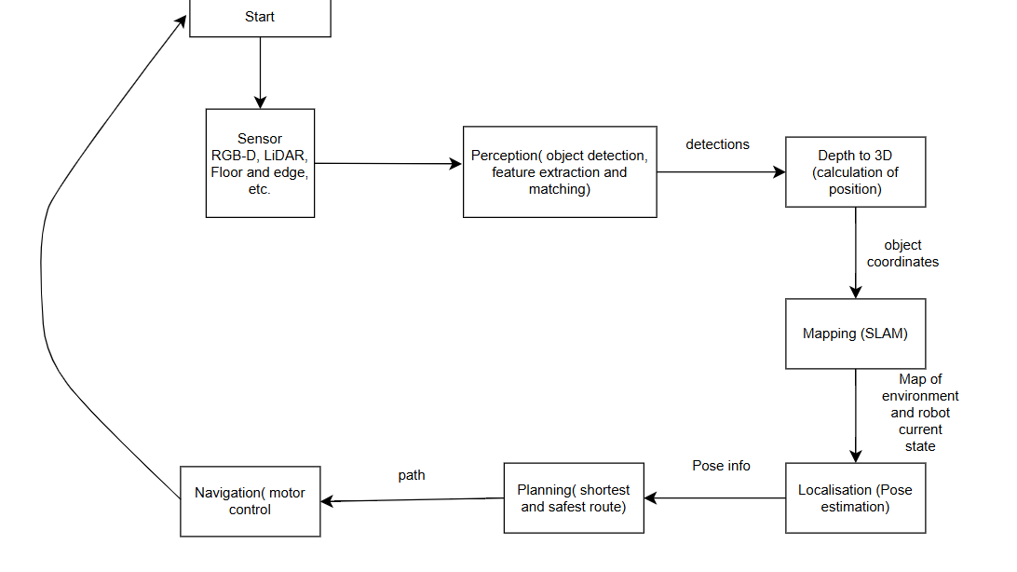

ROS TOPICS AND FRAMES

|  |  |  |  |
| --- | --- | --- | --- |
| **Module** | **Example ROS 2 Topic** | **Data Type/ Message** | **Frame** |
| Sensors | /rgb_image_topic  /imu_data, /lidar, /floor, /proximity,  /fused_map | /sensor_msgs/image,  sensor_msg/laser,  sensor_msg/imu | Camera_link,  Base_link |
| Perception | /detected_objects | Vision_msg/detection3darr | Camer_link |
| Mapping | /map | nav_msg/occupancyGrid | Map |
| Localization | /odom | nav_msg/odometry | Odom |
| Planning | /path | nav_msgs/path | Map |
| Navigation | /cmd_vel | geometry_msg/grasp | Base_link |

The ROS2 dataflow diagram illustrates how the robot’s perception, planning and control modules interact. Sensor nodes publish data to specific topics, which are fused by a sensor Fusion Node. The fused data is processed by the YOLOx detection node and passed to the SI-ACO path planner to generate an optimized path. Finally, the Motion Control converts the planned path into velocity commands, while the safety nodes monitor for obstacles and triggers emergency stops if needed. Consider this diagram below.

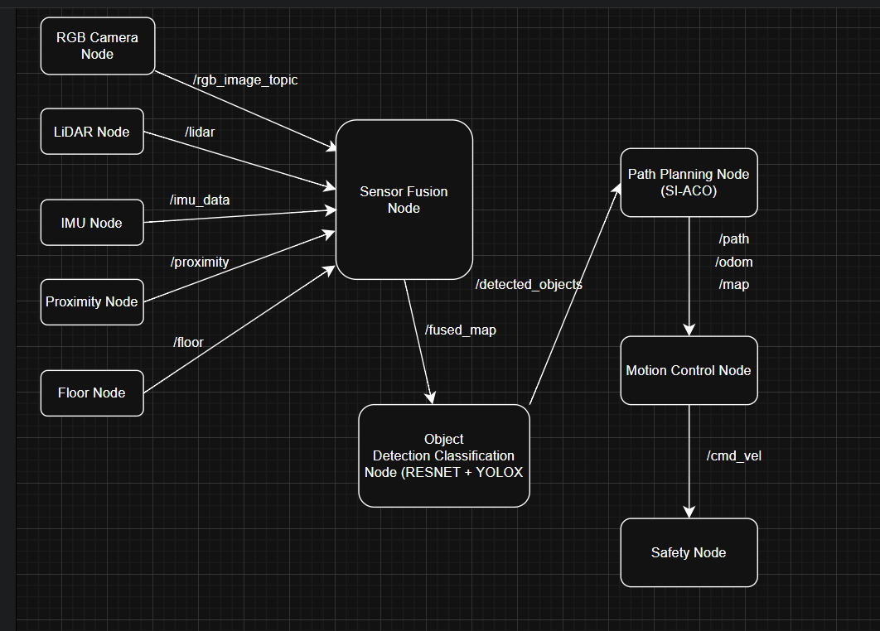

Data Model and Plan

Risk and Safety:

Operating in interior office settings, Aerius frequently interacts with people and fragile objects. As a result, safety features are incorporated into both software and hardware to stop accidents, injuries, and system damage. According to ISO 10218-1 (Robots and Robotic Devices — Safety Requirements for Industrial Robots) and ISO 13482 (Safety Requirements for Personal Care Robots) (International Organisation for Standardisation, 2011; 2014), each safeguard is made to function automatically under particular circumstances.

**Emergency Stop (E-stop)**

Description: When physically pressed or remotely activated using the companion app, a dedicated emergency stop system instantly stops all motions (rail, arm, or suction modules).

Activation Scenario: When anomalous conditions are identified (such as abrupt force resistance or a human being near the minimum safety radius), the E-stop is triggered by a person or an automated safety trigger. Brakes engage immediately after the arm and rail motors are de-energised.

Justification: According to ISO 13850, e-stop systems are a category 3 safety circuit, guaranteeing dependable, fail-safe shutdowns in the case of malfunctions or unforeseen human situations (International Organisation for Standardisation, 2015). In their safety white paper, KUKA Robotics also underlined the significance of a hardwired emergency stop for collaborative robots (KUKA Robotics, 2021).

**Speed Caps**

Description: Software-enforced restrictions known as speed limitations stop the ceiling rail or arm joints from moving too much.

Activation Scenario: Constantly active when Aerius uses shared workspaces with people. When PIR motion detectors or proximity sensors detect movement from people close, the speed automatically decreases.

Justification: By keeping kinetic energy below harm limits (usually less than 80 J for general contact), speed caps guarantee adherence to ISO/TS 15066, which establishes safe speeds for human–robot collaboration (International Organisation for Standardisation, 2016). Universal Robots (2020) also emphasises human-safe speed regulation in collaborative situations, promoting safe operation in shared areas.

**Minimum Obstacle Distance**

Description: Aerius uses information from corner sensors, depth cameras, and LiDAR to dynamically determine a safety buffer. The buffer establishes the smallest permitted separation between any person or item and the robot's moving parts.

Activation Scenario: Aerius slows down or stops until the obstruction is removed when an object reaches the minimum range, which is normally between 30 and 50 cm. Aerius uses its A* path planner to recalculate a different route if the object continues to exist.

Justification: In accordance with ISO 10218-2:2011, which places a strong emphasis on protecting collaborative robots through proximity detection and speed reduction, maintaining a minimum obstacle distance lowers the likelihood of collisions (International Organisation for Standardisation, 2011). Siemens' robotics safety guidelines likewise emphasise similar safety procedures (Siemens, 2022).

**Fallback Mode (Detection and Localise Failure)**

Description: When essential sensors (LiDAR, IMU, and depth camera) malfunction or localisation confidence falls below a certain point (for example, because of poor light or reflective surfaces), Fallback Mode makes sure that Aerius switches to a safe state.

Activation Scenario: Initiated when the robot's self-diagnostic module identifies faulty data, localisation drift, or sensor disconnection. Aerius halts motion, pulls back its telescopic arm, and uses its last known coordinates to head back to its ceiling dock.

Justification: Fallback methods guarantee that the robot never operates blindly by utilising fail-operational design principles. ISO/TR 13309, which promotes safe system degradation in robotic systems, is in line with these methods (International Organisation for Standardisation, 2018). In their safety application notes, NVIDIA discusses similar fail-safe fallback and sensor redundancy solutions (NVIDIA, 2023).

**Proximity & Force Feedback Protection**

Description: To identify unexpected resistance or human contact, Aerius incorporates proximity sensors within its soft-grip mechanism and arm.

Activation Scenario: The arm stops and retracts instantly when force sensors identify resistance beyond the calibrated threshold (such as bumping a chair or hand). Prior to starting up again, vision-based monitoring verifies clearance.

Justification: To lower the possibility of pinching or impact accidents, force-feedback safety is crucial for collaborative robots, or cobots. This is in line with the guidelines established by ISO/TS 15066, which establishes safe boundaries for human-robot interaction (International Organisation for Standardisation, 2016). The significance of force limitation and compliance in collaborative safety systems is further emphasised by ABB Robotics (2021).

**Thermal, Electrical, and System Safety**

Description: The rail power network and arm actuators of Aerius are equipped with a temperature regulation system, current monitoring, and overload protection.

Activation Scenario: Initiated when threshold values for either system temperature or current are exceeded. When the robot stops, it transmits diagnostic data to the maintenance interface.

Justification: By avoiding electrical dangers and overheating, these precautions guarantee the durability and fire safety of ceiling-mounted devices. Compliance is in line with NASA's robotic safety standards (NASA, 2020) and IEC 60204-1:2016 for electrical equipment safety (International Electrotechnical Commission, 2016).

**Human Presence & Occupancy Detection**

Description: AI-based human detection (via an RGB-D camera) and PIR motion sensors make sure Aerius doesn't fly over or close to workers while they're moving or cleaning.

Activation Scenario: When a human is identified within Aerius' operating radius, all motion is stopped. After the zone is clear, the motion resumes.

Justification: Human detection-based operational control lowers liability in shared offices and guarantees adherence to safety regulations for collaborative workspaces. This complies with ISO 13482:2014's safety standards (International Organisation for Standardisation, 2014). Boston Dynamics also emphasises human-safe operational techniques (2021).

## Validation and Testing of Aerius Safety Mechanisms

**Collision Tests**

Purpose: Make sure Aerius stops before coming into contact with people or items. Verifies the effectiveness of LiDAR fusion, proximity sensors, and floor corner sensors in preventing collisions. Compliance complies with the safety regulations for industrial robot systems set forth in ISO 10218-2:2011 (International Organisation for Standardisation, 2011).

Scenario: During rail transit or arm extension, a person's hand, chair, or other object enters the 30-cm safety buffer.

Approach: Put test objects and dummies in the robot's working area. Calculate the time it takes to detect and halt motion.

Expected Result: The robot stops within ≤200 ms while keeping the specified minimum obstacle distance.

**E-Stop Test**

Purpose: Verify the capacity to shut down quickly in an emergency. complies with ISO 13850:2015 emergency stop standards by guaranteeing that hardware-level fail-safe functions in both regular and unusual circumstances (International Organisation for Standardisation, 2015).

Scenario: During active motion, the E-stop is manually pressed or activated through an app.  
  
Approach: Test in different operating zones and speeds (rail motion, arm extension, hoover active). Time it takes for the system to completely stop.  
  
Expected Result: Within ≤250 ms, the robot stops all actuators.  
The hoover shuts off, the arm retracts and the rail locks.

**Sensor Failure Test**

Purpose: In the event that the primary sensors fail, make careful to act safely. complies with ISO/TR 13309:2018's fail-safe design guidelines by confirming redundancy in the sensor fusion system (LiDAR, depth camera, and floor sensors) and preventing uncontrollable behaviour (International Organisation for Standardisation, 2018).

Scenario: Turning off LiDAR or obstructing the depth camera feed while the robot is in motion.

Approach: In a controlled setting, temporarily mimic sensor dropout. Check to see if the fallback mechanisms, arm retractions, rail locks, and micro-vacuum shutdowns, are engaged.

Expected Result: The robot instantly switches to a safe fallback state and awaits manual intervention or recovery.

**Speed-Cap Verification**

Purpose: Make sure all axes' motion limitations are adhered to. verifies that safety margins are appropriately enforced by the path planner and software-based speed limits (International Organisation for Standardisation, 2016).

Scenario: The robot fully extends its arm or travels across ceiling rails at the highest speed instructed.

Approach: Measure the velocities of the arms and rails using encoder logs or high-speed motion capture cameras. Test while carrying a variety of office supplies.

Expected Result: Maximum speed ≤0.3 m/s for rails and ≤0.2 m/s for arm extension, in compliance with ISO/TS 15066:2016 safety standards for human robot dialogue.

**Arm Force / Torque Response Test**

Purpose: Verify the safety response in the event that the soft-grip arm experiences unexpected resistance. Verifies compliance with ISO/TS 15066:2016 force limits for collaborative robot interactions (International Organisation for Standardisation, 2016) regarding arm safety and human contact.

Scenario: Use a hand or item to represent an impediment in the arm's path of motion.

Approach: The arm goes towards the impediment. Resistance is measured by force/torque sensors. Check to see if the arm retracts and the action stops.

Expected Result: The arm automatically stops and retracts, causing no harm to the robot or object.

**Thermal / Electrical Overload Test**

Purpose: Make sure the robot doesn't work in hazardous temperatures or currents. Verifies that ceiling-mounted situations are safe for overcurrent and thermal protection in accordance with IEC 60204-1:2016 electrical equipment standards (International Electrotechnical Commission, 2016).

Scenario: Model prolonged use or a partial obstruction that results in a higher motor load.

Approach: Keep an eye on the onboard current and heat sensors. Check for speed reduction or automatic shutdown when criteria are surpassed.

Expected Result: The robot stops or minimises its activity; the maintenance app receives diagnostic notifications.

**Human Occupancy / Motion Test**

Purpose: Make sure Aerius stays still when people are around. complies with ISO 13482:2014 safety regulations for personal care and collaborative robots (International Organisation for Standardisation, 2014) by confirming human-aware scheduling and motion to avoid collisions in busy office zones.

Scenario: As the robot completes tasks, a human pass beneath the operational zone.

Approach: Human presence is detected using PIR sensors and AI-powered vision. Watch how the robot reacts as the arm is deployed and the rail moves.

Expected Result: The robot will cease its movement until the space is clear.

Below is a safety/fallback decision flow:

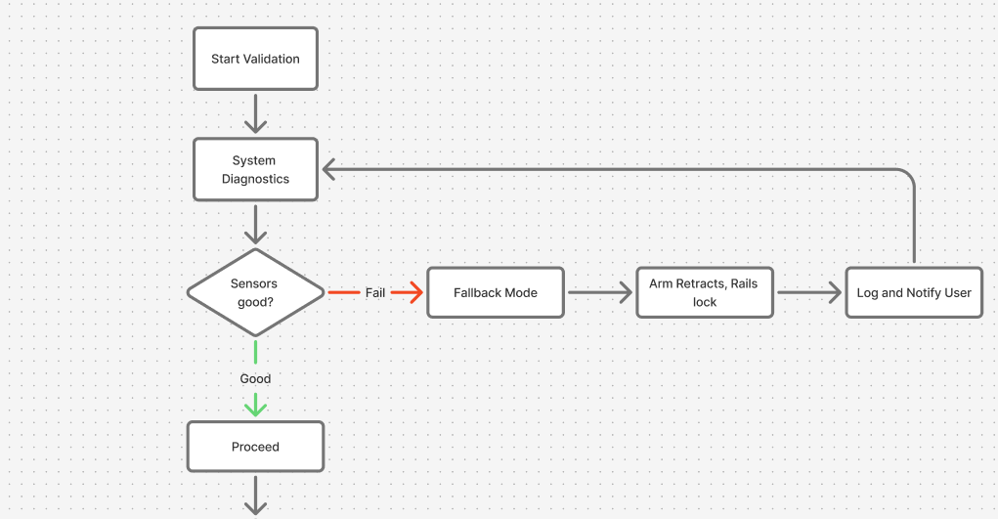

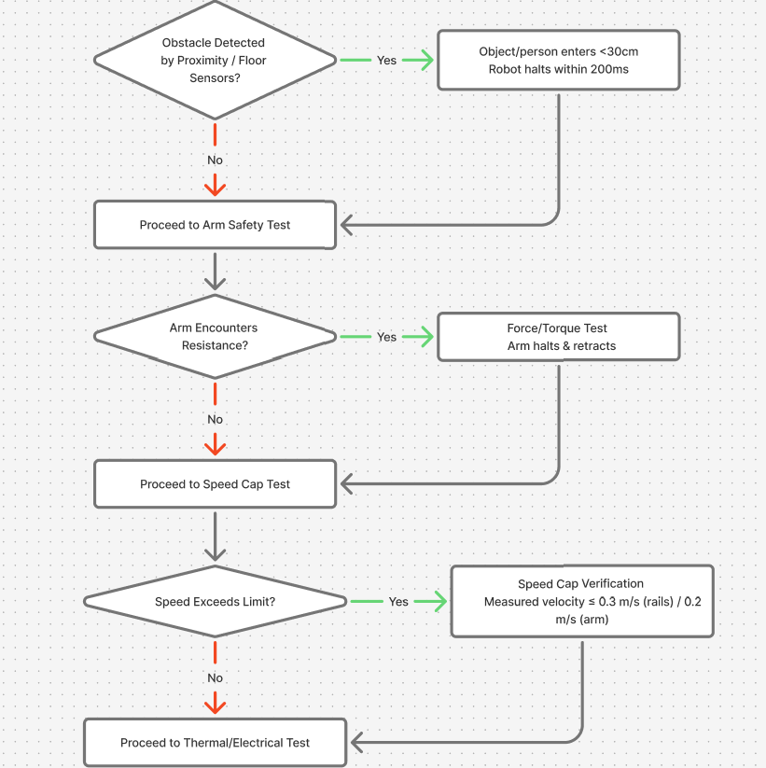

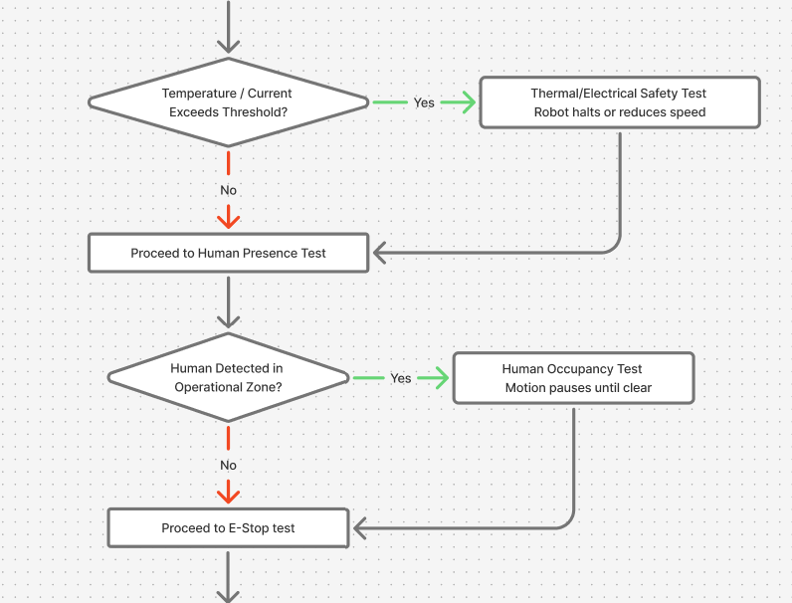

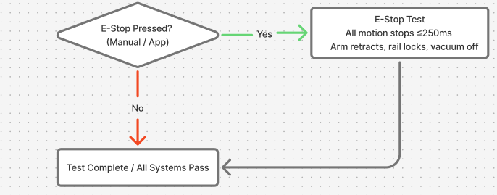

Budget / BOM

|  |  |  |  |  |
| --- | --- | --- | --- | --- |
| Category | Component | Selected component and price | Alternative(s) and price | Reference |
| Sensor | RGB Camera | Logitech Brio 4K: $200 | Intel RealSense D415:  $180  Raspberry Pi HQ Camera:  $70 | Logitech, 2025; Amazon, 2025 |
|  | RGB-D | OAK-D (Luxonis): $350 | Intel RealSense D435:  $280  ZED Mini:  $450 | Luxonis, 2025; Digi-Key, 2025 |
|  | 2D LiDAR | RPLIDAR A3:  $600 | Hokuyo UST-20LX: $900  Slamtec RPLIDAR S2:  $650 | SLAMTEC, 2025; Amazon, 2025 |
|  | IMU | Bosch BNO055: $35 | MPU-9250:  $15  Adafruit 9-DOF: $25 | Bosch, 2025; Digi-Key, 2025 |
|  | AprilTags | AprilTag v2: $10/set | ArUco Markers:  $8/set  QR Codes:  $5/set | Luxonis, 2025; Amazon, 2025 |
|  | Floor Corner Sensors | Sharp IR:  $15 | Ultrasonic:  $20  Floor Pressure: $30 | Sharp, 2025; Digi-Key, 2025 |
|  | Temp & Air Quality | Bosch BME680: $40 | Sensirion SGP30: $35 | Bosch, 2022; Digi-Key, 2025 |
|  | Safety Proximity | HC-SR04:  $5 | VL53L1X ToF:  $20 | SparkFun, 2023; Microelectronics STM, 2022 |
|  | Shelf Vibration | MEMS + accelerometer:  $10 | Piezo pickup:  $5 | STMicroelectronics, 2023; SparkFun, 2023 |
|  | Ceiling Light Sensor | FLIR Lepton:  $200 | Melexis MLX90640:  $120  Seek Thermal Compact Pro:  $250 | FLIR, 2023; Melexis, 2023 |

|  |  |  |  |  |
| --- | --- | --- | --- | --- |
| Category | Component | Selected component and price | Alternative(s) and price | Reference |
| Manipulation / Arm | Telescopic Robotic Arm | UFactory xArm 6 DoF:  $1,200 | Dobot Magician: $600  Custom Linear Arm:  $800 | UFactory, 2025 |
|  | Arm Linear Actuator | Electric Linear Actuator:  $150 | Pneumatic Cylinder:  $120 | Firgelli Automations, 2023 |
|  | Soft-Grip End Effector | Robotiq 2F-85: $400 | OnRobot RG2: $350  Custom 3D-printed:  $50 | Robotiq, 2025 |
|  | Ceiling Rail Actuators | Stepper Motor Linear Gantry: $800 | Servo-driven actuators:  $900  Custom belt-pulley:  $500 | Oriental Motor, 2025 |
|  | Slip Ring / Rotary Feed | Ethernet + power slip ring:  $100 | Flexible harness + torsion limiters:  $80 | Moog, 2023 |
|  | Rail Controller | Trinamic TMC stepper drivers: $150 | Servo drive Delta/Kollmorgen: $250 | Trinamic, 2023 |
|  | Ceiling Mount Frame | Custom Aluminum CNC: $300 | 3D-printed mount:  $100 | Bosch Rexroth, 2023 |
| Control | Onboard Processing Unit | Intel NUC i7 / NVIDIA Jetson Xavier NX:  $650 / $600 | Raspberry Pi 4:  $70  Jetson Nano:  $150 | Intel, 2025; NVIDIA, 2025 |
| Communication | Microphone Array | ReSpeaker 6-Mic:  $60 | Logitech Mic Array:  $50  MEMS:  $20 | ReSpeaker, 2023 |
|  | Speaker | Small onboard: $20 | Piezo:  $5 | Adafruit, 2023 |
|  | Visual Feedback | 2.4” TFT + LED Ring:  $25 | Single-color LED matrix:  $15 | Adafruit, 2023 |
| Cleaning/ Maintenance | HEPA Dust Filter | HEPA13 + prefilter:  $50 | Electrostatic + washable:  $60 | Honeywell, 2023 |
|  | Sensor Cleaning | Air-jet + wiper:  $30 | Ultrasonic / electrostatic:  $50 | |  | | --- | |  |  |  | | --- | | DustTech, 2023 | |
|  | Vacuum Motor | Nidec 24V DC:  $75 | Dyson V6 / Mabuchi RS-775:  $150 / $60 | Bosch, 2023; Mabuchi Motor, 2023 |
| Safety | Emergency Stop | Schneider XB4: $25 | Omron A165E:  $20 | Schneider Electric, 2023 |
|  | Proximity Sensors | ToF + capacitive strips:  $60 | Mechanical bump + IR:  $30 | STMicroelectronics, 2023; Microchip, 2023 |
|  | Cooling / Thermal | PWM Fan + heatsink:  $30 | Passive / Peltier: $40 | Noctua, 2023; NVIDIA, 2023 |
| Power/Networking | Ceiling Power Supply | Hardwired:  $70 | Anker Docking Station:  $150 | MeanWell, 2023; Anker, 2023 |
|  | Battery Backup | Li-ion 12V 10Ah:  $50 | LiFePO4 / Lead-Acid:  $80 / $60 | Panasonic, 2023; A123 Systems, 2023 |
|  | PoE Switch | Managed PoE+ 48V:  $120 | Unmanaged PoE:  $50 | Cisco, 2023 |

Reference list

A123 Systems. (2023) LiFePO4 Battery Solutions – Specifications and Safety Data. Available at: <https://www.a123systems.com> / (Accessed on: 16 October 2025).

ABB Robotics (2021) Collaborative safety and force limitation standards. Zurich: ABB Ltd. Available at: <https://new.abb.com/products/robotics> (Accessed on: 19 October 2025).

Adafruit. (2023) 2.4" TFT Display Modules and RGB LED Rings. Available at: <https://www.adafruit.com/> (Accessed on: 16 October 2025).

Adafruit. (2023) Speakers and Audio Modules for Embedded Systems. Available at: https://www.adafruit.com/ (Accessed on: 16 October 2025).

Adafruit. (2025). Adafruit 9-DOF Absolute Orientation IMU Fusion Breakout. Available at: <https://www.adafruit.com/product/2472> (Accessed on 14 October 2025).

Anker. (2023) Wireless Charging Solutions and Battery Management. Available at: <https://www.anker.com/products/a83b3-anker-prime-charging-docking-station-14-in-1-triple-display-140w?ref=image_product_shelf> (Accessed: 16 October 2025).

Bosch Rexroth. (2023) Industrial Aluminum Profiles and Structural Framing Systems. Available at: <https://www.boschrexroth.com/> (Accessed on: 16 October 2025).

Bosch Sensortec. (2025). Smart Sensor BNO055. Available at: <https://www.bosch-sensortec.com/products/smart-sensor-systems/bno055/> (Accessed on 14 October 2025).

Bosch. (2022) BME680 Environmental Sensor. Available at: <https://www.bosch-sensortec.com/products/environmental-sensors/gas-sensors/bme680/> (Accessed on: 16 October 2025).

Bosch. (2023) High-Torque Motors for Continuous Operation. Available at: <https://www.bosch.com/> (Accessed on: 16 October 2025).

Boston Dynamics (2021) Safety practices for human-robot collaboration. Waltham, MA: Boston Dynamics, Inc. Available at: <https://www.bostondynamics.com/> (Accessed on: 19 October 2025).

Brother International Corporation via StartupNation, 2011. P-touch Means Business survey: disorganization causes 76 working hours lost per employee annually, equating to over USD 177 billion in wasted time. In: StartupNation, “Lost Time Equals Wasted Dollars: Tips for Small Business Workers to Stay Efficient. Available at: <https://startupnation.com/grow-your-business/run-your-business-better/lost-time-equals-wasted-dollars-tips-for-small-business-workers-to-stay-efficient/> (Accessed on 09 October 2025).

Circuit Cellar. (2021). Build a Robotic Arm with Linear Actuators. Available at: <https://circuitcellar.com/research-design-hub/projects/build-a-robotic-arm-with-linear-actuators/> (Accessed on 14 October 2025).

Cisco. (2023) Managed Power over Ethernet (PoE) Switches – Features and Configuration. Available at: <https://www.cisco.com/> (Accessed on: 16 October 2025).

Cooler Master. (2023) Thermal Management Solutions - Heatsinks and Peltier Modules. Available at: <https://www.coolermaster.com/> (Accessed on: 16 October 2025).

Dobot. (2025). Dobot Magician - Desktop 4-Axis Robotic Arm, Education Package. Available at: <https://profound3d.com/products/dobot-magician-4-axis-robotic-arm-education-package> (Accessed on 14 October 2025).

DustTech. (2023) Air-Jet and Wiper Systems for Optical Equipment Maintenance. Available at: <https://www.dusttech.com/> (Accessed on: 16 October 2025).

Dyson. (2023) Digital Motor V6 – Product Specifications. Available at: <https://www.dyson.com/> (Accessed on: 16 October 2025).

Dyson. (2023) Electrostatic Air Filters and Precipitators. Available at: <https://www.dyson.com/> (Accessed on: 16 October 2025).

Firgelli Automations. (2023) Linear Electric Actuators – Product Overview. Available at: <https://www.firgelliauto.com/> (Accessed on: 16 October 2025).

He, F., Liu, T. and Tao, D. (2020) ‘Why ResNet Works? Residuals Generalize’, IEEE transaction on neural networks and learning systems, 31(12), pp. 5349–5362. Available at: https://doi.org/10.1109/TNNLS.2020.2966319. (Accessed on 20 October 2025)

Hokuyo. (2025). Hokuyo UST-20LX Scanning Laser Rangefinder. Available at: <https://www.hokuyo-usa.com/products/lidar-obstacle-detection/ust-20lx> (Accessed on 14 October 2025).

Honeywell. (2023) HEPA Air Filters – Product Information. Available at: <https://www.honeywell.com/> (Accessed on: 16 October 2025).

Honeywell. (2025). Floor Pressure Sensors. Available at: <https://sensing.honeywell.com/floor-pressure-sensors> (Accessed on 14 October 2025).

Intel. (2025). Intel NUC Mini PCs. Available at: <https://www.intel.com/content/www/us/en/products/boards-kits/nuc.html> (Accessed on 14 October 2025).

Intel. (2025). Intel® RealSense™ Depth Camera D415. Available at: <https://www.intel.com/content/www/us/en/products/sku/128256/intel-realsense-depth-camera-d415/specifications.html> (Accessed on 14 October 2025).

Intel. (2025). Intel® RealSense™ Depth Camera D435. Available at: <https://www.intel.com/content/www/us/en/products/sku/128255/intel-realsense-depth-camera-d435/specifications.html> (Accessed on 14 October 2025).

International Electrotechnical Commission (IEC) (2016) IEC 60204-1:2016 Safety of machinery- Electrical equipment of machines - Part 1: General requirements. Geneva: IEC. Available at: <https://www.iec.ch/> (Accessed on: 19 October 2025).

International Organization for Standardization (ISO) (2011) ISO 10218-2:2011 Robots and robotic devices-Safety requirements for industrial robots-Part 2: Robot systems and integration. Geneva: ISO. Available at: <https://www.iso.org/standard/41571.html> (Accessed on: 19 October 2025).

International Organization for Standardization (ISO) (2018) ISO/TR 13309:2018 Robots and robotic devices- Guidelines for fail-safe design in robotics. Geneva: ISO. Available at: <https://www.iso.org/standard/70829.html> (Accessed on: 19 October 2025).

International Organization for Standardization (ISO). (2011) ISO 10218-1:2011 Robots and robotic devices- Safety requirements for industrial robots- Part 1: Robots. Geneva: ISO. Available at: <https://www.iso.org/standard/51330.html> (Accessed on: 19 October 2025).

International Organization for Standardization (ISO). (2014) ISO 13482:2014 Robots and robotic devices- Safety requirements for personal care robots. Geneva: ISO. Available at: <https://www.iso.org/standard/53820.html> (Accessed on: 19 October 2025).

International Organization for Standardization (ISO). (2015) ISO 13850:2015 Safety of machinery- Emergency stop function - Principles for design. Geneva: ISO. Available at: <https://www.iso.org/standard/52600.html> (Accessed on: 19 October 2025).

International Organization for Standardization (ISO). (2016) ISO/TS 15066:2016 Robots and robotic devices- Collaborative robots. Geneva: ISO. Available at: <https://www.iso.org/standard/62996.html> (Accessed on: 19 October 2025).

InvenSense. (2025). MPU-9250 - InvenSense. Available at: <https://invensense.tdk.com/products/motion-tracking/9-axis/mpu-9250/> (Accessed on 14 October 2025).

Knowles. (2023) MEMS Microphones – Product Overview. Available at: <https://www.knowles.com/> (Accessed on: 16 October 2025).

KUKA Robotics. (2021) Safety in collaborative robotics: White Paper. Augsburg: KUKA AG. Available at: <https://www.kuka.com> (Accessed on: 19 October 2025).

Li, Z., Lai, B. and Pan, Y. (2024) ‘Image-Based Composite Learning Robot Visual Servoing With an Uncalibrated Eye-to-Hand Camera’, IEEE/ASME transactions on mechatronics, 29(4), pp. 2499–2509. Available at: https://doi.org/10.1109/TMECH.2023.3341914. (Accessed on 15 October 2025)

Logitech. (2023) Conference and Microphone Array Solutions. Available at: <https://www.logitech.com/> (Accessed on: 16 October 2025).

Logitech. (2025). Logitech BRIO Webcam with 4K Ultra HD Video & HDR. Available at: <https://www.logitech.com/en-us/products/webcams/brio-4k-hdr-webcam.html> (Accessed on 14 October 2025).

Luxonis. (2025). AprilTag vs ArUco markers. Available at: <https://robotics.stackexchange.com/questions/19901/apriltag-vs-aruco-markers> (Accessed on 14 October 2025).

Luxonis. (2025). Localization and navigation using QR code for mobile robot. Available at: <https://www.semanticscholar.org/paper/Localization-and-navigation-using-QR-code-for-robot-Zhang-Zhang/c0aa0b18f55cbb3978e8ee47caad2683e7d4c9ce> (Accessed on 14 October 2025).

Luxonis. (2025). OAK-D. Available at: <https://shop.luxonis.com/products/oak-d> (Accessed on 14 October 2025).

Luxonis. (2025). QR Code Based Navigation. Available at: <https://skemman.is/bitstream/1946/41726/1/QR%20Code%20Based%20Navigation.pdf> (Accessed on 14 October 2025).

Luxonis. (2025). QR-code based Localization for Indoor Mobile Robot with Artificial Landmark. Available at: <https://jrkwon.com/wordpress/wp-content/uploads/2023/02/AIM-2015-Final.pdf> (Accessed on 14 October 2025).

Luxonis. (2025). Virtual Experiments on ArUco and AprilTag Systems Comparison for Fiducial Marker Rotation Resistance under Noisy Sensory Data. Available at: <https://www.researchgate.net/publication/347020537_Virtual_Experiments_on_ArUco_and_AprilTag_Systems_Comparison_for_Fiducial_Marker_Rotation_Resistance_under_Noisy_Sensory_Data> (Accessed on 14 October 2025).

Mabuchi Motor. (2023) RS-775 DC Motor - Product Information. Available at: <https://www.mabuchi-motor.com/> (Accessed on: 16 October 2025).

Maker Pro. (2025). Designing and Building Belt-Driven Linear Motion Systems. Available at: <https://maker.pro/linear-motion> (Accessed on 14 October 2025).

MaxBotix. (2025). Ultrasonic Rangefinder Sensors. Available at: <https://www.maxbotix.com/ultrasonic_sensors> (Accessed on 14 October 2025).

MeanWell. (2023) Continuous Power Supplies for Industrial Applications. Available at: <https://www.meanwell.com/newsInfo.aspx?c=1&i=1456> (Accessed on: 16 October 2025).

Melexis. (2023) MLX90640 Thermal Infrared Sensor – Product Documentation. Available at: <https://www.melexis.com/> (Accessed on: 16 October 2025).

Microchip. (2023) Capacitive Touch Sensors - Product Documentation. Available at: <https://www.microchip.com/> (Accessed on: 16 October 2025).

Moog. (2023) Slip Rings for Industrial Automation. Available at: <https://www.moog.com/> (Accessed on: 16 October 2025).  
Hangzhou Grand Technology. (2023) Through-Bore Slip Rings and Flexible Cable Solutions. Available at: <https://www.grandslipring.com/> Accessed on: 16 October 2025).

Nano-Clean. (2023) Ultrasonic Dust Removal and Electrostatic Coatings. Available at: <https://www.nano-clean.com/> (Accessed on: 16 October 2025).

NASA (2020) NASA safety standards for robotics. Washington, DC: National Aeronautics and Space Administration. Available at: <https://www.nasa.gov/> (Accessed on: 19 October 2025).

Netgear. (2023) Unmanaged PoE Switches and Injectors – Product Overview. Available at: <https://www.netgear.com/> (Accessed on: 16 October 2025).

Noctua. (2023) PWM Fans and Active Cooling Solutions. Available at: <https://noctua.at/> (Accessed on: 16 October 2025).

NVIDIA (2023) Jetson safety application notes: Fail-safe fallback and sensor redundancy strategies. Santa Clara, CA: NVIDIA Corporation. Available at: <https://developer.nvidia.com/embedded> (Accessed on: 19 October 2025).

NVIDIA. (2023) Jetson Thermal Design and Cooling Recommendations. Available at: <https://developer.nvidia.com/embedded/jetson-thermals> (Accessed on: 16 October 2025).

NVIDIA. (2025). NVIDIA Jetson Xavier NX Developer Kit. Available at: <https://developer.nvidia.com/embedded/jetson-xavier-nx> (Accessed on 14 October 2025).

Omron. (2023) A165E Series Emergency Stop Switches - Product Specifications. Available at: <https://www.omron.com/> (Accessed on: 16 October 2025).

OnRobot. (2025). RG2 – Flexible 2 Finger Robot Gripper with Wide Stroke. Available at: <https://onrobot.com/us/products/rg2-gripper> (Accessed on 14 October 2025).

Open Robotics. (2025). ROS 1 Melodic Morenia Documentation. Available at: <https://docs.ros.org/en/melodic/index.html> (Accessed on 14 October 2025).

Open Robotics. (2025). ROS 2 Documentation. Available at: <https://docs.ros.org/en/rolling/index.html> (Accessed on 14 October 2025).

Oriental Motor. (2025). Stepper Motor Gantry Systems for Precision Motion. Available at: <https://www.orientalmotor.com/products/stepper-motors/gantry-systems.html> (Accessed on 14 October 2025).

Panasonic. (2023) Lithium-Ion Batteries for High-Energy Applications. Available at: <https://www.panasonic.com/> (Accessed on: 16 October 2025).

Raspberry Pi. (2025). Buy a Raspberry Pi High Quality Camera. Available at: <https://www.raspberrypi.com/products/raspberry-pi-high-quality-camera/> (Accessed on 14 October 2025).

Raspberry Pi. (2025). Raspberry Pi 4 Model B. Available at: <https://www.raspberrypi.com/products/raspberry-pi-4-model-b/> (Accessed on 14 October 2025).

ReSpeaker. (2023) ReSpeaker Microphone Array – Voice Interface for AI and Robotics. Available at: <https://wiki.seeedstudio.com/ReSpeaker_Mic_Array/> (Accessed: 16 October 2025).

Robotiq. (2025). Adaptive Grippers. Available at: <https://robotiq.com/products/adaptive-grippers> (Accessed on 14 October 2025).

Schneider Electric. (2023) Industrial Emergency Stop Switches. Available at: <https://www.se.com/> (Accessed on: 16 October 2025).

Seek Thermal. (2023) Seek Compact Pro – Thermal Imaging Camera. Available at: <https://www.thermal.com/> (Accessed on: 16 October 2025).

Sensirion. (2022) SGP30 Indoor Air Quality Sensor. Available at: <https://sensirion.com/products/catalog/SGP30/> (Accessed on: 16 October 2025).

Sharp. (2023) Infrared Proximity Sensors - Product Overview. Available at: https://www.sharpsma.com / (Accessed on: 16 October 2025).

Sharp. (2025). Sharp Infrared Sensors. Available at: <https://www.sharpsma.com/products/infrared-sensors> (Accessed on 14 October 2025).

Siemens (2022) Robotics safety guidelines. Munich: Siemens AG. Available at: <https://new.siemens.com> (Accessed on: 19 October 2025).

Siemens. (2023) Servo Drives and Motion Control Systems. Available at: <https://www.siemens.com/> (Accessed on: 16 October 2025).

SLAMTEC. (2025). RPLIDAR A3. Available at: <https://www.slamtec.com/en/Lidar/A3Spec> (Accessed on 14 October 2025).

SLAMTEC. (2025). RPLIDAR S2. Available at: <https://www.slamtec.com/en/S2/Spec> (Accessed on 14 October 2025).

SMC Corporation. (2023) Pneumatic Cylinders – Product Catalogue. Available at: <https://www.smc.eu/> (Accessed on: 16 October 2025).

SMC. (2025). Servo Actuators and Linear Motion Solutions. Available at: <https://www.smcworld.com/en-us/products/linear-actuators> (Accessed on 14 October 2025).

SparkFun. (2023) Distance Sensor Product Documentation. Available at: <https://www.sparkfun.com/> (Accessed on: 16 October 2025).

SparkFun. (2023) Mechanical Bump and Limit Switch Sensors. Available at: <https://www.sparkfun.com/> (Accessed on: 16 October 2025).  
SparkFun. (2023) Piezo Vibration Sensor Product Page. Available at: <https://www.sparkfun.com/> (Accessed on: 16 October 2025).

SparkFun. (2023) Piezo Vibration and Sound Sensors. Available at: <https://www.sparkfun.com/> (Accessed on: 16 October 2025).

Stereolabs. (2025). ZED Mini Stereo Camera. Available at: <https://www.stereolabs.com/store/products/zed-mini> (Accessed on 14 October 2025).

STMicroelectronics. (2023) MEMS Accelerometer Product Documentation. Available at: <https://www.st.com/> (Accessed on: 16 October 2025).

STMicroelectronics. (2023) Time-of-Flight Sensors for Distance Measurement. Available at: <https://www.st.com/> (Accessed on: 16 October 2025).

Think Robotics. (2025). Designing a 3D Printed Gripper for a Robotic Arm. Available at: <https://thinkrobotics.com/blogs/learn/designing-a-3d-printed-gripper-for-a-robotic-arm> (Accessed on 14 October 2025).

Trinamic Motion Control. (2023) Stepper Motor Drivers and Motion Control Solutions. Available at: <https://www.trinamic.com/> (Accessed on: 16 October 2025).

Trojan Battery. (2023) Lead-Acid Battery Solutions. Available at: <https://www.trojanbattery.com/> (Accessed on: 16 October 2025).

UFactory. (2025). xArm 6 DoF Robotic Arm. Available at: <https://www.robotshop.com/products/xarm-6-dof-robotic-arm> (Accessed on 14 October 2025).

Ultimaker. (2023) 3D Printing Solutions for Prototyping and Manufacturing. Available at: <https://www.ultimaker.com/> (Accessed on: 16 October 2025).

Universal Robots. (2020) Human-safe speed regulation in co-working environments. Odense: Universal Robots A/S. Available at: <https://www.universal-robots.com> (Accessed on: 19 October 2025).

Wang, H. et al. (2025) ‘A Survey of the Multi-Sensor Fusion Object Detection Task in Autonomous Driving’, Sensors (Basel, Switzerland), 25(9), p. 2794. Available at: https://doi.org/10.3390/s25092794. (Accessed on 20 October 2025)

Waveshare. (2023) LED Matrix and E-Ink Displays. Available at: <https://www.waveshare.com/> (Accessed on: 16 October 2025).

Wu, S., Yan, Y. and Wang, W. (2023) ‘CF-YOLOX: An Autonomous Driving Detection Model for Multi-Scale Object Detection’, Sensors (Basel, Switzerland), 23(8), p. 3794. Available at: https://doi.org/10.3390/s23083794. (Accessed on 20 October 2025)

Zhang, J., Hu, Z. and Wang, X. (2023) ‘Research on Global Path Planning of Robot Based on Ant Colony Algorithm and Gaussian Sampling’, Mathematical problems in engineering. Edited by Y. Zhang, 2023(1). Available at: https://doi.org/10.1155/2023/4194568. (Accessed on 20 October 2025)